INTEGRANTES:



Cinemática de Robots.

Avance 1  
ROBOT ANTROPOMORFICO

Prof.: Carlos Enrique Moran Garabito

**Salguero Hernández Juan Pablo**

**Martínez Jacinto Ricardo**

**Avalos Lupercio Jesús Jail**

**García barajas Raúl Israel**

**Rubio García Rodrigo**

Cinemática de robots

Brazo robótico

**2019**

**Diseño:**

En el diseño del brazo robotico antropomorfico se utilizaron 3 grados de libertad y 3 eslabones, de los cuales una articulacion rotativa y otras dos articulaciones comunes.

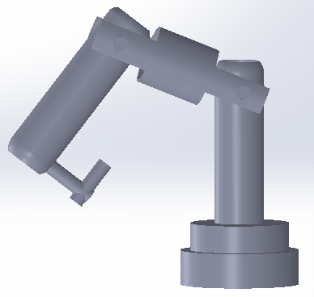

El primer eslabon se encuentra seccionado para poder lograr el movimiento rotativo del primer eslabon, el eslabon fijo se diseño de la siguiente forma:

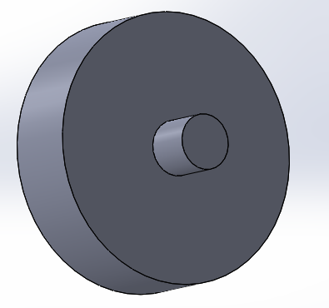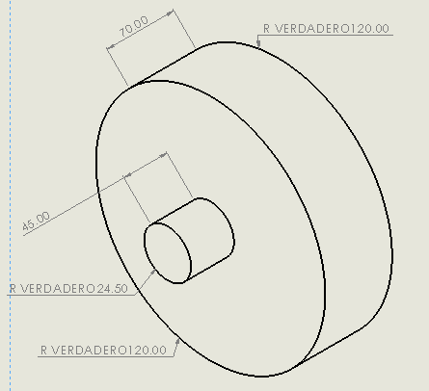

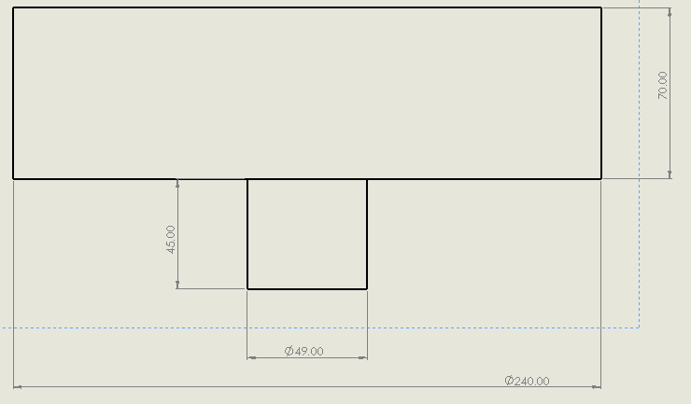

Este eslabon fijo junto al primer eslabon seran los que contengan la articulacion para el movimiento giratorio del brazo robotico.

El suiguiente es el eslabon 1 el cual tiene como requisito una altura minima de 33 cm y como se puede observar en el diseño el requisito es cumplido.

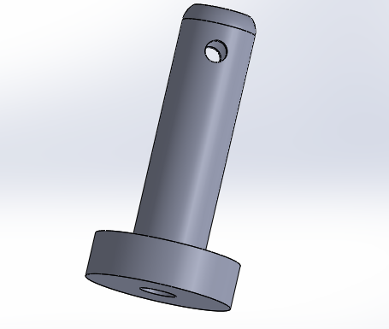

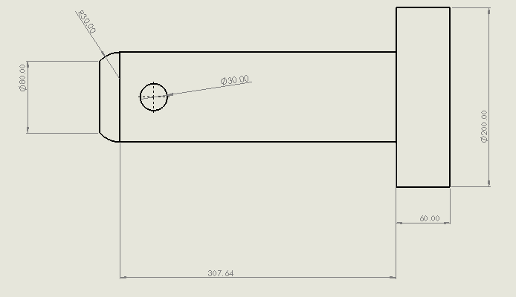

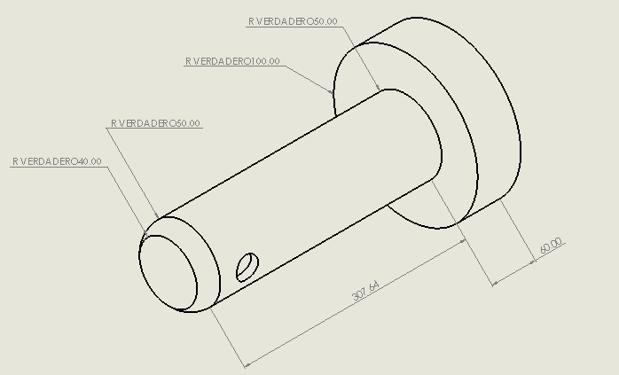

En el eslabón 2 se procuró elaborar una pieza donde la mayor parte del material se concentre en el centro, para que esta pieza sea resistente ya que es lugar en el eslabón 2 donde se encuentran esfuerzos considerables.

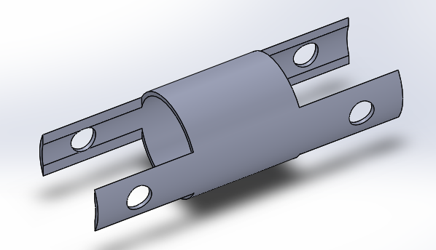

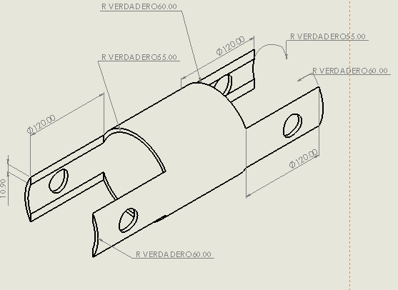

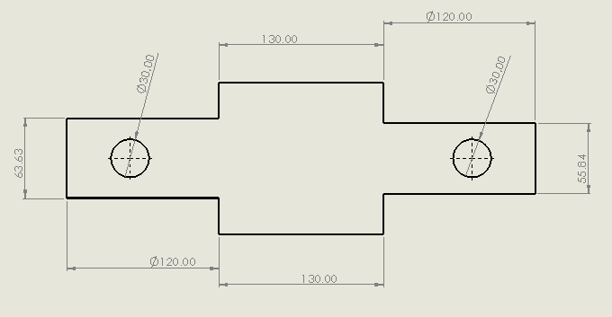

En el eslabón tres se optó por un pequeño gancho donde se colocará el peso de los 250gr. 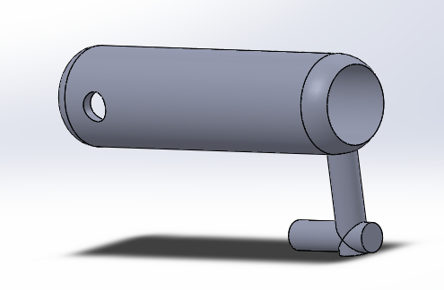

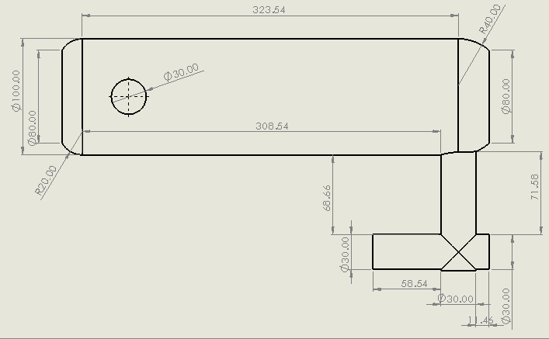

Para la unión de las piezas se utilizarán ejes de 2.5 cm de diámetro.

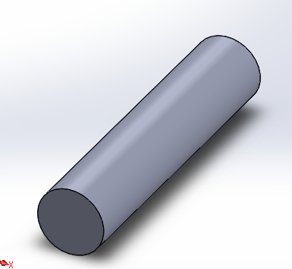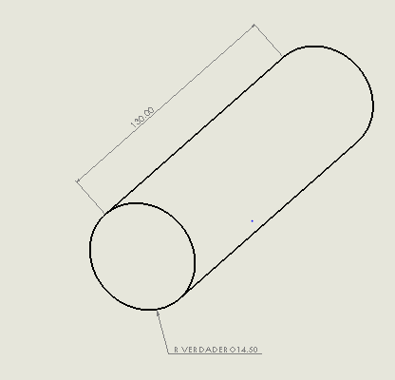

**Simulación en Ansys:**

En el Software de Ansys los resultados que se obtuvieron al realizar un análisis estructural arrojaron que el eslabón 3 estará sometido a grandes esfuerzos comparado con los otros eslabones, por lo cual se tendrá especial atención tanto al motor de la articulación entre el eslabón 2-3 así como al espesor y material del ultimo eslabón.

Lo positivo que se encuentra en el análisis en Ansys es que ninguno de los eslabones sufre un esfuerzo tan grande como para deformar o generar un fallo en alguno de los eslabones del robot.



**Project**

|  |  |
| --- | --- |
| First Saved | Thursday, January 31, 2019 |
| Last Saved | Thursday, January 31, 2019 |
| Product Version | 19.1 Release |
| Save Project Before Solution | No |
| Save Project After Solution | No |

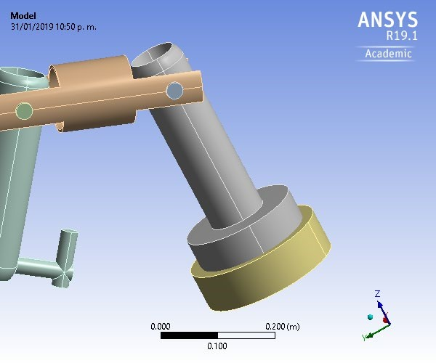

# Contents

* **Units**
* **Model (A4)** o Geometry
  + Parts o Materials
  + Structural Steel
  + PVC Foam (60 kg m^-3) o Coordinate Systems o Connections
  + Contacts
  + Contact Regions o Mesh

o **Static Structural (A5)**

* + Analysis Settings
  + Loads
  + Solution (A6)
  + Solution Information
  + Total Deformation
* **Material Data** o PVC Foam (60 kg m^-3)

# Units

**TABLE 1**

|  |  |
| --- | --- |
| Unit System | Metric (m, kg, N, s, V, A) Degrees rad/s Celsius |
| Angle | Degrees |
| Rotational Velocity | rad/s |
| Temperature | Celsius |

# Model (A4)

## Geometry

**TABLE 2**

**Model (A4) > Geometry**

|  |  |
| --- | --- |
| Object Name | *Geometry* |
| State | Fully Defined |
| **Definition** | |
| Source | C:\Users\ricar\Downloads\Ensamblaje1.SAT |
| Type | ACIS |
| Length Unit | Millimeters |
| Element Control | Program Controlled |
| Display Style | Body Color |
| **Bounding Box** | |
| Length X | 0.24 m |
| Length Y | 0.5915 m |
| Length Z | 0.56722 m |
| **Properties** | |
| Volume | 7.5148e-003 m³ |
| Mass | 0.45089 kg |
| Scale Factor Value | 1. |
| **Statistics** | |
| Bodies | 6 |
| Active Bodies | 6 |
| Nodes | 7449 |
| Elements | 3269 |
| Mesh Metric | None |
| **Update Options** | |
| Assign Default Material | No |
| **Basic Geometry Options** | |
| Solid Bodies | Yes |
| Surface Bodies | Yes |
| Line Bodies | No |
| Parameters | Independent |
| Parameter Key | ANS;DS |
| Attributes | No |
| Named Selections | No |
| Material Properties | No |
| **Advanced Geometry Options** | |
| Use Associativity | Yes |
| Coordinate Systems | No |
| Reader Mode Saves Updated File | No |
| Use Instances | Yes |
| Smart CAD Update | Yes |
| Compare Parts On Update | No |
| Analysis Type | 3-D |
| Mixed Import Resolution | None |
| Decompose Disjoint Geometry | Yes |
| Enclosure and Symmetry Processing | Yes |

**TABLE 3 Model (A4) > Geometry > Parts**

|  |  |  |  |  |  |  |
| --- | --- | --- | --- | --- | --- | --- |
| Object Name | *Part 1* | *Part 2* | *Part 3* | *Part 4* | *Part 5* | *Part 6* |
| State |  | Meshed | | |  |  |
|  |  | **Graphics Properties** | | |  |  |
| Visible |  | Yes | | |  |  |
| Transparency |  | 1 | | |  |  |
|  |  | **Definition** | | |  |  |
| Suppressed |  | No | | |  |  |
| Stiffness Behavior |  | Flexible | | |  |  |
| Coordinate System |  | Default Coordinate Syste | | | m |  |
| Reference  Temperature | By Environment | | | | | |
| Behavior | None | | | | | |
| **Material** | | | | | | |
| Assignment | PVC Foam (60 kg m^-3) | | | | | |
| Nonlinear Effects | Yes | | | | | |
| Thermal Strain Effects | Yes | | | | | |
| **Bounding Box** | | | | | | |
| Length X | 0.2 m | 0.13 m | | 0.12 m | 0.1 m | 0.24 m |
| Length Y | 0.2 m | 2.9e-002 m | | 0.36507 m | 0.28982 m | 0.24 m |
| Length Z | 0.39 m | 2.9e-002 m | | 0.19537 m | 0.40608 m | 0.115 m |
| **Properties** | | | | | | |
| Volume | 2.6678e-003 m³ | 8.489e-005 m³ | | 3.3863e-004 m³ | 1.0997e-003 m³ | 3.2388e-003 m³ |
| Mass | 0.16007 kg | 5.0934e-003 kg | | 2.0318e-002 kg | 6.5985e-002 kg | 0.19433 kg |
| Centroid X | -2.1442e002 m | -2.0376e002 m | -2.0411e002 m | -2.2199e002 m | -2.1205e002 m | -2.1442e002 m |
| Centroid Y | -1.9941e-002 m | | 0.22996 m | 0.10903 m | 0.30709 m | -1.9941e002 m |
| Centroid Z | 0.28845 m | 0.525 m | 0.62722 m | 0.57776 m | 0.5068 m | 0.16649 m |
| Moment of Inertia Ip1 | 2.1001e-003 kg·m² | 5.2936e-007 kg·m² | | 1.4711e-004 kg·m² | 8.9273e-004 kg·m² | 7.7403e-004 kg·m² |
| Moment of Inertia Ip2 | 2.0985e-003 kg·m² | 7.4379e-006 kg·m² | | 6.7182e-005 kg·m² | 8.1876e-004 kg·m² | 7.7403e-004 kg·m² |
| Moment of Inertia Ip3 | 6.6596e-004 kg·m² | 7.4379e-006 kg·m² | | 1.6504e-004 kg·m² | 1.9244e-004 kg·m² | 1.3593e-003 kg·m² |
| **Statistics** | | | | | | |
| Nodes | 1588 | 305 | | 2551 | 1984 | 716 |
| Elements | 775 | 48 | | 1096 | 963 | 339 |
| Mesh Metric | None | | | | | |

## Coordinate Systems

### TABLE 4

**Model (A4) > Coordinate Systems > Coordinate System**

|  |  |
| --- | --- |
| Object Name | *Global Coordinate System* |
| State | Fully Defined |
| **Definition** | |
| Type | Cartesian |
| Coordinate System ID | 0. |
| **Origin** | |
| Origin X | 0. m |
| Origin Y | 0. m |
| Origin Z | 0. m |
| **Directional Vectors** | |
| X Axis Data | [ 1. 0. 0. ] |
| Y Axis Data | [ 0. 1. 0. ] |
| Z Axis Data | [ 0. 0. 1. ] |

## Connections

### TABLE 5 Model (A4) > Connections

|  |  |
| --- | --- |
| Object Name | *Connections* |
| State | Fully Defined |
| **Auto Detection** | |
| Generate Automatic Connection On Refresh | Yes |
| **Transparency** | |
| Enabled | Yes |

### TABLE 6

**Model (A4) > Connections > Contacts**

|  |  |
| --- | --- |
| Object Name | *Contacts* |
| State | Fully Defined |
| **Definition** | |
| Connection Type | Contact |
| **Scope** | |
| Scoping Method | Geometry Selection |
| Geometry | All Bodies |
| **Auto Detection** | |
| Tolerance Type | Slider |
| Tolerance Slider | 0. |
| Tolerance Value | 2.1348e-003 m |
| Use Range | No |
| Face/Face | Yes |
| Face Overlap Tolerance | Off |
| Cylindrical Faces | Include |
| Face/Edge | No |
| Edge/Edge | No |
| Priority | Include All |
| Group By | Bodies |
| Search Across | Bodies |
| **Statistics** | |
| Connections | 6 |
| Active Connections | 6 |

### TABLE 7

**Model (A4) > Connections > Contacts > Contact Regions**

|  |  |  |  |  |  |  |
| --- | --- | --- | --- | --- | --- | --- |
| Object Name | *Contact Region* | *Contact Region 2* | *Contact Region 3* | *Contact Region 4* | *Contact Region 5* | *Contact Region 6* |
| State |  | | Fully Defined | | | |
|  |  | | **Scope** | | | |
| Scoping Method |  | | Geometry Selection | | | |
| Contact | 4 Faces | 3 Faces | 2 Faces | | | 4 Faces |
| Target | 2 Faces | 3 Faces | 4 Faces | | | 2 Faces |
| Contact Bodies | Part 1 | | Part 2 | Part 3 | | Part 4 |
| Target Bodies | Part 2 | Part 6 | Part 4 | | Part 5 | |
| Protected |  | | No | | | |
|  | **Definition** | | | | | |
| Type | Bonded | | | | | |
| Scope Mode | Automatic | | | | | |
| Behavior | Program Controlled | | | | | |
| Trim Contact | Program Controlled | | | | | |
| Trim Tolerance | 2.1348e-003 m | | | | | |
| Suppressed | No | | | | | |
|  | **Advanced** | | | | | |
| Formulation | Program Controlled | | | | | |
| Small Sliding | Program Controlled | | | | | |
| Detection Method | Program Controlled | | | | | |
| Penetration Tolerance | Program Controlled | | | | | |
| Elastic Slip Tolerance | Program Controlled | | | | | |
| Normal Stiffness | Program Controlled | | | | | |
| Update Stiffness | Program Controlled | | | | | |
| Pinball Region | Program Controlled | | | | | |
|  | **Geometric Modification** | | | | | |
| Contact Geometry Correction | None | | | | | |
| Target Geometry Correction | None | | | | | |

## Mesh

**TABLE 8**

**Model (A4) > Mesh**

|  |  |
| --- | --- |
| Object Name | *Mesh* |
| State | Solved |
| **Display** |  |
| Display Style | Body Color |
| **Defaults** |  |
| Physics Preference | Mechanical |
| Element Order | Program Controlled |
| Element Size | Default |
| **Sizing** |  |
| Use Adaptive Sizing | Yes |
| Resolution | Default (2) |
| Mesh Defeaturing | Yes |
| Defeature Size | Default |
| Transition | Fast |
| Span Angle Center | Coarse |
| Initial Size Seed | Assembly |
| Bounding Box Diagonal | 0.85394 m |
| Average Surface Area | 9.6923e-003 m² |
| Minimum Edge Length | 1.3427e-003 m |
| **Quality** |  |
| Check Mesh Quality | Yes, Errors |
| Error Limits | Standard Mechanical |
| Target Quality | Default (0.050000) |
| Smoothing | Medium |
| Mesh Metric | None |
| **Inflation** | |
| Use Automatic Inflation | None |
| Inflation Option | Smooth Transition |
| Transition Ratio | 0.272 |
| Maximum Layers | 5 |
| Growth Rate | 1.2 |
| Inflation Algorithm | Pre |
| View Advanced Options | No |
| **Advanced** | |
| Number of CPUs for Parallel Part Meshing | Program Controlled |
| Straight Sided Elements | No |
| Number of Retries | Default (4) |
| Rigid Body Behavior | Dimensionally Reduced |
| Triangle Surface Mesher | Program Controlled |
| Topology Checking | Yes |
| Pinch Tolerance | Please Define |
| Generate Pinch on Refresh | No |
| **Statistics** | |
| Nodes | 7449 |
| Elements | 3269 |

# Static Structural (A5)

## TABLE 9 Model (A4) > Analysis

|  |  |
| --- | --- |
| Object Name | *Static Structural (A5)* |
| State | Solved |
| **Definition** | |
| Physics Type | Structural |
| Analysis Type | Static Structural |
| Solver Target | Mechanical APDL |
| **Options** | |
| Environment Temperature | 22. °C |
| Generate Input Only | No |

## TABLE 10

**Model (A4) > Static Structural (A5) > Analysis Settings**

|  |  |
| --- | --- |
| Object Name | *Analysis Settings* |
| State | Fully Defined |
|  | **Step Controls** |
| Number Of Steps | 1. |
| Current Step Number | 1. |
| Step End Time | 1. s |
| Auto Time Stepping | Program Controlled |
| **Solver Controls** | |
| Solver Type | Program Controlled |
| Weak Springs | Off |
| Solver Pivot Checking | Program Controlled |
| Large Deflection | Off |
| Inertia Relief | Off |
| **Rotordynamics Controls** | |
| Coriolis Effect | Off |
| **Restart Controls** | |
| Generate Restart Points | Program Controlled |
| Retain Files After Full Solve | No |
| Combine Restart Files | Program Controlled |
| **Nonlinear Controls** | |
| Newton-Raphson Option | Program Controlled |
| Force Convergence | Program Controlled |
| Moment Convergence | Program Controlled |
| Displacement Convergence | Program Controlled |
| Rotation Convergence | Program Controlled |
| Line Search | Program Controlled |
| Stabilization | Off |
| **Output Controls** | |
| Stress | Yes |
| Strain | Yes |
| Nodal Forces | No |
| Contact Miscellaneous | No |
| General Miscellaneous | No |
| Store Results At | All Time Points |
| **Analysis Data Management** | |
| Solver Files Directory | C:\Users\ricar\Desktop\123_files\dp0\SYS-1\MECH\ |
| Future Analysis | None |
| Scratch Solver Files Directory |  |
| Save MAPDL db | No |
| Contact Summary | Program Controlled |
| Delete Unneeded Files | Yes |
| Nonlinear Solution | No |
| Solver Units | Active System |
| Solver Unit System | mks |

## TABLE 11

**Model (A4) > Static Structural (A5) > Loads**

|  |  |  |  |
| --- | --- | --- | --- |
| Object Name | *Fixed Support* | *Force* | *Remote Force* |
| State | Fully Defined | | |
| **Scope** | | | |
| Scoping Method | Geometry Selection | | |
| Geometry | 4 Faces 3 Faces | | 1 Face |
| Coordinate System |  | | Global Coordinate System |
| X Coordinate |  | | 4.4624e-002 m |
| Y Coordinate |  | | -1.9941e-002 m |
| Z Coordinate |  | | 0.525 m |
| Location |  | | Defined |
| **Definition** | | |  |
| Type | Fixed Support | Force | Remote Force |
| Suppressed | No | |  |
| Define By |  |  | Vector |
| Magnitude |  | 3. N (ramped) | 11. N (ramped) |
| Direction |  |  | Defined |
| Behavior |  | | Deformable |
| **Advanced** | | |  |
| Pinball Region |  | | All |

**FIGURE 1**

**Model (A4) > Static Structural (A5) > Force**

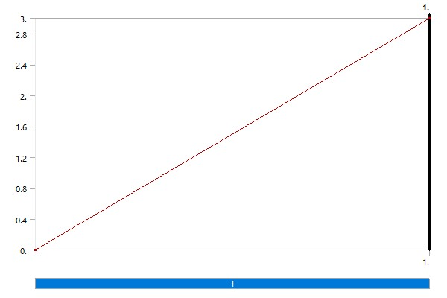

**FIGURE 2**

**Model (A4) > Static Structural (A5) > Remote Force**

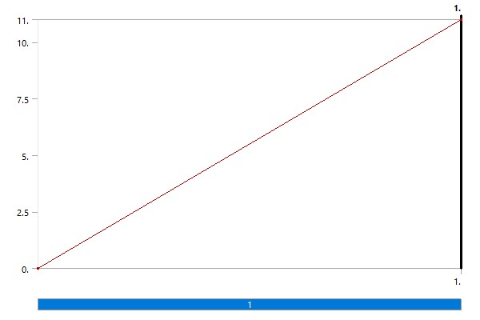

## Solution (A6)

### TABLE 12 Model (A4) > Static Structural (A5) > Solution

|  |  |
| --- | --- |
| Object Name | *Solution (A6)* |
| State | Solved |
| **Adaptive Mesh Refinement** | |
| Max Refinement Loops | 1. |
| Refinement Depth | 2. |
| **Information** | |
| Status | Done |
| MAPDL Elapsed Time | 16. s |
| MAPDL Memory Used | 281. MB |
| MAPDL Result File Size | 3.5625 MB |
| **Post Processing** | |
| Beam Section Results | No |
| On Demand Stress/Strain | No |

### TABLE 13 Model (A4) > Static Structural (A5) > Solution (A6) > Solution Information

|  |  |
| --- | --- |
| Object Name | *Solution Information* |
| State | Solved |
| **Solution Information** | |
| Solution Output | Solver Output |
| Newton-Raphson Residuals | 0 |
| Identify Element Violations | 0 |
| Update Interval | 2.5 s |
| Display Points | All |
| **FE Connection Visibility** | |
| Activate Visibility | Yes |
| Display | All FE Connectors |
| Draw Connections Attached To | All Nodes |
| Line Color | Connection Type |
| Visible on Results | No |
| Line Thickness | Single |
| Display Type | Lines |

### TABLE 14 Model (A4) > Static Structural (A5) > Solution (A6) > Results

|  |  |
| --- | --- |
| Object Name | *Total Deformation* |
| State | Solved |
| **Scope** | |
| Scoping Method | Geometry Selection |
| Geometry | All Bodies |
| **Definition** | |
| Type | Total Deformation |
| By | Time |
| Display Time | Last |
| Calculate Time History | Yes |
| Identifier |  |
| Suppressed | No |
| **Results** | |
| Minimum | 0. m |
| Maximum | 2.282e-003 m |
| Average | 1.1903e-003 m |
| Minimum Occurs On | Part 6 |
| Maximum Occurs On | Part 4 |
| **Information** | |
| Time | 1. s |
| Load Step | 1 |
| Substep | 1 |
| Iteration Number | 1 |

### FIGURE 3

**Model (A4) > Static Structural (A5) > Solution (A6) > Total Deformation**

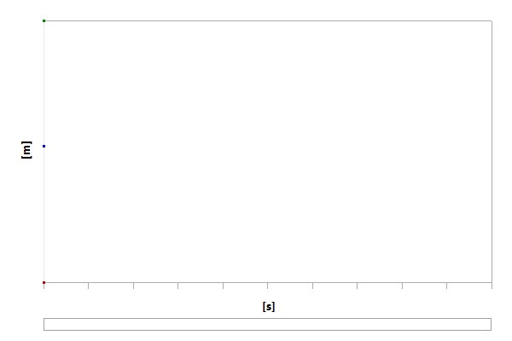

### TABLE 15

**Model (A4) > Static Structural (A5) > Solution (A6) > Total Deformation**

|  |  |  |  |
| --- | --- | --- | --- |
| Time [s] | Minimum [m] | Maximum [m] | Average [m] |
| 1. | 0. | 2.282e-003 | 1.1903e-003 |

### FIGURE 4

**Model (A4) > Static Structural (A5) > Solution (A6) > Total Deformation > Figure**

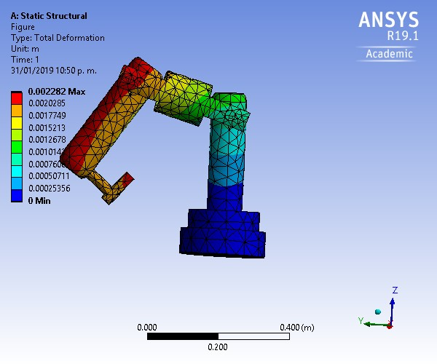

# Material Data

## PVC Foam (60 kg m^-3)

|  |  |  |  |  |  |  |  |  |
| --- | --- | --- | --- | --- | --- | --- | --- | --- |
| Tensile X direction Pa | Tensile Y direction Pa | Tensile Z direction Pa | Compressive  direction Pa | Compressive  Y direction Pa | Compressive  Z direction Pa | Shear XY Pa | Shear  YZ Pa | Shear  XZ Pa |

### TABLE 16 PVC Foam (60 kg m^-3) > Density

|  |
| --- |
| Density kg m^-3 |
| 60 |

### TABLE 17 PVC Foam (60 kg m^-3) > Isotropic Elasticity

|  |  |  |  |
| --- | --- | --- | --- |
| Young's Modulus Pa | Poisson's Ratio | Bulk Modulus Pa | Shear Modulus Pa |
| 7.e+007 | 0.3 | 5.8333e+007 | 2.6923e+007 |

### TABLE 18 PVC Foam (60 kg m^-3) > Orthotropic Stress Limits

|  |  |  |  |  |  |  |  |  |
| --- | --- | --- | --- | --- | --- | --- | --- | --- |
| 1.5e+006 | 1.5e+006 | 9.5e+005 | -1.5e+006 | -1.5e+006 | -9.5e+005 | 9.3e+005 | 9.3e+005 | 9.3e+005 |

**TABLE 19**

**PVC Foam (60 kg m^-3) > Color**

|  |  |  |
| --- | --- | --- |
| Red | Green | Blue |
| 155 | 244 | 255 |